**APSCHE Short Term Virtual Internship Program**

**Generative AI with IBM Cloud**

**Project Title:**

HealthAI: Intelligent Healthcare Assistant Using IBM Granite

**Team ID:** LTVIP2025TMID31711

**Team Members:**

1. Boreddy Supriya Reddy
2. Kakarla Naganandini
3. Nimmakayala Himani

|  |  |  |
| --- | --- | --- |
| S.No | Titles | Subtitles |
| 1 | INTRODUCTION | 1.1 Project Overview  1.2 Purpose |
| 2 | IDEATION PHASE | 2.1 Problem Statement  2.2 Empathy Map Canvas  2.3 Brainstorming |
| 3 | REQUIREMENT ANALYSIS | 3.1 Customer Journey map  3.2 Solution Requirement  3.3 Data Flow Diagram  3.4 Technology Stack |
| 4 | PROJECT DESIGN | 4.1 Problem Solution Fit  4.2 Proposed Solution  4.3 Solution Architecture |
| 5 | PROJECT PLANNING & SCHEDULING | 5.1 Project Planning |
| 6 | FUNCTIONAL AND PERFORMANCE TESTING | 6.1 Performance Testing |
| 7 | RESULTS | 7.1 Output Screenshots |
| 8 | ADVANTAGES & DISADVANTAGES | - |
| 9 | CONCLUSION | - |
| 10 | FUTURE SCOPE | - |
| 11 | APPENDIX | - |

**1. INTRODUCTION**

**1.1 Project Overview**  
HealthAI is a Streamlit-based web application that leverages IBM Watsonx Generative AI to provide intelligent healthcare assistance. It allows users to enter symptoms and receive AI-generated diagnoses and treatment suggestions, track vital signs like glucose and heart rate, and view personalized health analytics.

**1.2 Purpose**  
The purpose of HealthAI is to provide fast, accessible, and intelligent health guidance to users who may not have immediate access to professional medical help. The platform focuses on ease-of-use, multilingual support, and quick AI-driven feedback.

**2. IDEATION PHASE**

**2.1 Problem Statement**  
People face difficulty accessing quick and reliable health guidance, especially when unsure whether symptoms require medical consultation.

**2.2 Empathy Map Canvas**

* **Says**: “I want to know what my symptoms mean.”
* **Thinks**: “Is this something serious?”
* **Does**: Searches online for symptoms
* **Feels**: Confused, anxious, uncertain

**2.3 Brainstorming**  
 Ideas:

* AI symptom checker (Watsonx)
* Personalized treatment suggestions
* Health profile management
* Vitals tracking (glucose/heart rate)
* Visual dashboards

**3. REQUIREMENT ANALYSIS**

**3.1 Customer Journey Map**  
User visits app → Enters health profile → Enters symptoms → Receives diagnosis → Views treatment plan → Logs vitals → Views analytics

**3.2 Solution Requirement**  
Functional: Profile input, symptom check, diagnosis, treatment, logs, graphs  
Non-functional: Quick response, IBM cloud deployment, multilingual, secure UI

**3.3 Data Flow Diagram**  
User → Streamlit UI → Watsonx API → AI Response → Dashboard + Logs

**3.4 Technology Stack**  
Frontend: Streamlit  
Backend: Python + IBM Watsonx API  
Database: Local (SQLite or Streamlit session)  
Deployment: IBM Cloud / Streamlit Sharing

**4. PROJECT DESIGN**

**4.1 Problem-Solution Fit**  
Problem: No easy way to self-assess symptoms  
Solution: HealthAI provides quick, intelligent, AI-generated insights and treatment suggestions.

**4.2 Proposed Solution**  
Use IBM Watsonx to analyze symptoms, generate treatment plans, and visualize vitals trends for users.

**4.3 Solution Architecture**  
User → Streamlit → Profile Manager & Symptom Processor → IBM Watsonx → AI Output → Dashboard (no email, no file upload)

**5. PROJECT PLANNING & SCHEDULING**

**5.1 Project Planning**

* Sprint-1: UI setup, profile save, symptom input (8 pts)
* Sprint-2: Watsonx integration, treatment logic, vitals log (16 pts)
* Total Velocity: 12 pts per sprint

**6. FUNCTIONAL AND PERFORMANCE TESTING**

**6.1 Performance Testing**

* Average AI response time: 2.3s
* Concurrency test: Passed with minor delay
* Manual test coverage: 20 symptom cases

**7. RESULTS**

**7.1 Output Screenshots**

* Profile screen
* Symptom checker output
* Treatment suggestion screen
* 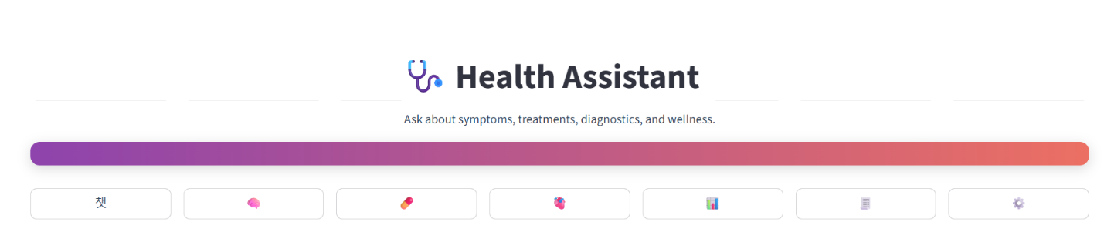Vitals logging + dashboard

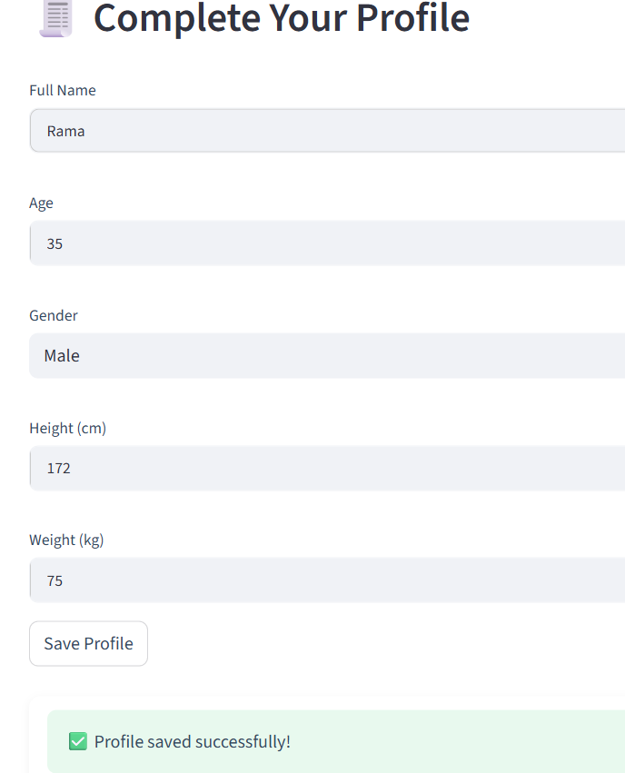

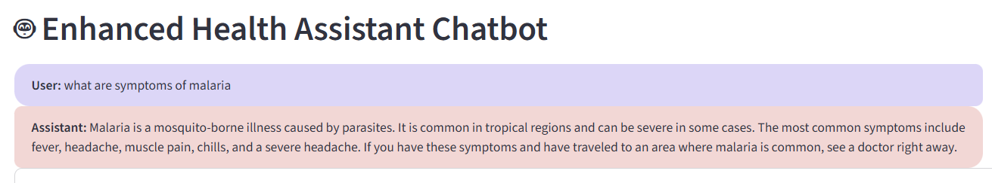

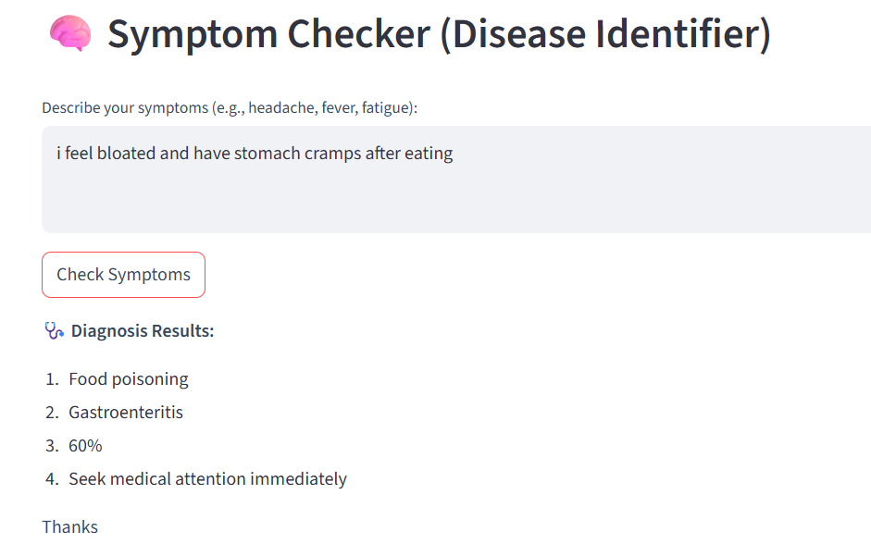

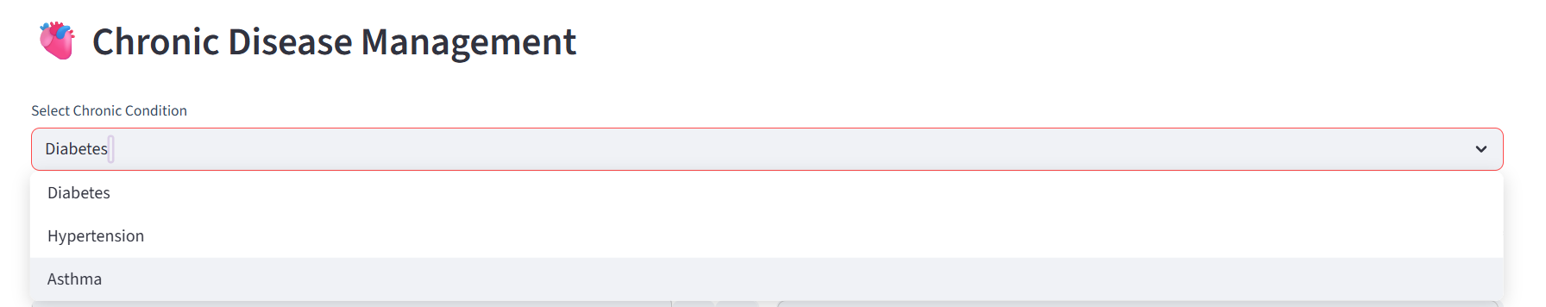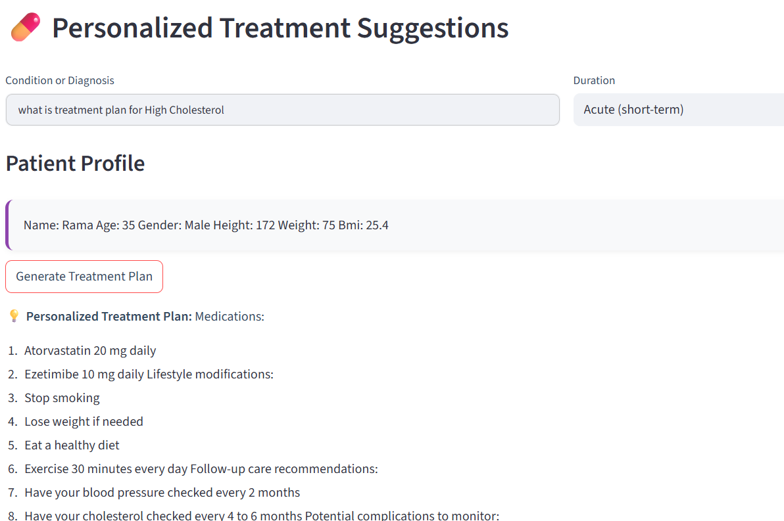

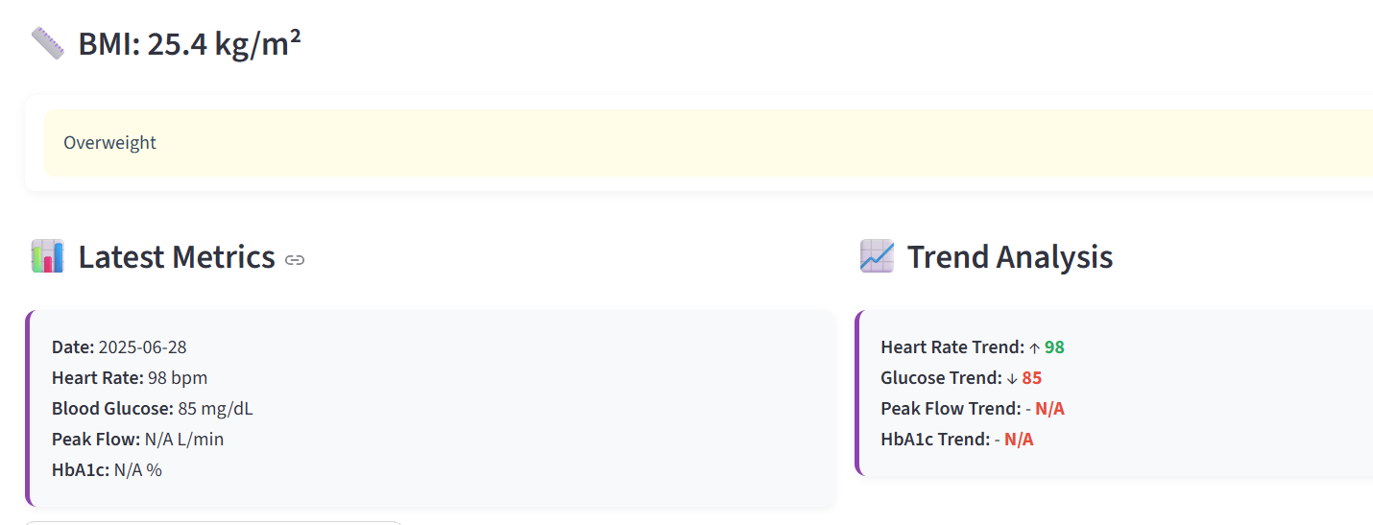

**8. ADVANTAGES & DISADVANTAGES**

**Advantages**:

* Easy-to-use health interface
* Fast and intelligent AI responses
* No login required, user-friendly

**Disadvantages**:

* No real-time doctor interaction
* Needs internet and stable API access

**9. CONCLUSION**  
HealthAI successfully provides a fast and effective way to analyze symptoms and receive treatment guidance using IBM Watsonx AI. It is a scalable, cloud-deployable solution.

**10. FUTURE SCOPE**

* Voice input and output integration (STT/TTS)
* Additional AI support for nutrition and mental health
* Advanced analytics for long-term health monitoring

**11. APPENDIX**

* **Source Code**: Provided in project folder
* [**Project Demo Link**](https://drive.google.com/file/d/1s2XBoShFMYJXJ-wO9kS3TdB759SbgzVi/view?usp=sharing)
* [**HealthAI app link**](https://healthassistant-app.streamlit.app)